**Lab Report No**: 04

**Name**: Ishrath Mostakin

**ID**: IT-17018

**Name of the lab report**: File Operation and Permission.

**Objective:** In this lab, we know a lot about the file operating system on Linux OS. The file system is the most obvious aspect of any OS. It provides users with storage and access to data as well as operating system programs.

**Q-1 : What is File Operation and File Permission in Linux Operating System?**

**File Operation :** As you know that files are used to store the required information for its later uses. The operating system can provide system calls to create, write, read, reposition, delete, and truncate files. There are many file operations that can be perform by the computer system.

Here are the list of some common file operations:

File Create operation

File Delete operation

File Open operation

File Close operation

File Read operation

File Write operation

File Append operation

File Seek operation

File Get attribute operation

File Set attribute operation

File Rename operation

**File Permissions :** There is a set of rules for each file which defines who can access that file, and how they can access in Linux and other Unix-like operating systems. These rules are called file permissions . The Linux permission model has three types of permission for each file system object. The permissions are read (r), write (w), and execute (x). Write permission includes the ability to alter or delete an object. In addition, these permissions are specified separately for the file’s owner, members of the file’s group, and everyone else.

Read: Read permission for a directory allows a user with that permission to list the contents of the directory. Without read permission on a directory, the file system objects inside the directory are not viewable in a directory listing, but these objects can still be accessed as long as you know the full path to the object on disk.

Write: Write permission means a user with that permission can create or delete files in the directory. The write permission on a directory gives you the authority to add, remove and rename files stored in the directory.

Execute: Execute permission allows the user to enter the directory and access any subdirectories. Without execute permission on a directory, the file system objects inside the directory are not accessible.

**Q-2 : Implementation of File Operation and File Permission**

**File-System Implementation**

file system consists of on-disk structure and in-memory structure

**On-disk structure**

1. Boot control block – information needed by the system to boot an OS from that disk. Typically the first block of a partition. Called boot block in UFS; partition boot sector in NTFS
2. Partition control block – partition detail s.t. the # of blocks, the size of the blocks, free-block count, freeblock pointers, and so forth. superblock (in UFS) or master file table (in NTFS)
3. Directory structure u file control block – file’s detail. file permission, ownership, size, location of the data block. inode (UFS)

**In-memory structure**

1. Used for file-system management and performance improvement via caching
2. In-memory partition table – information about each mounted partition
3. In-memory directory structure – holds the directory information of recently accessed directories
4. Per-process open-file table - has a pointer to the proper entry in system-wide open-file table, a pointer to the current location of the file for read/write operations.

**Adding Permissions :** When you first create the script, it will usually not be executable. Use the chmod command with the +x option to add the execute permissions.

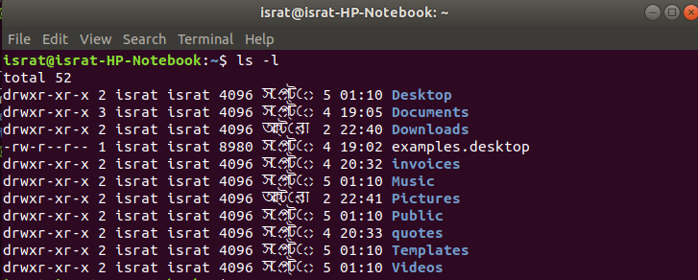

**Recursive Directory Listing :** ls -R : Use the ls command to get recursive directory listing on Linux. Find /dir/ -print : Run the find command to see recursive directory listing in Linux.

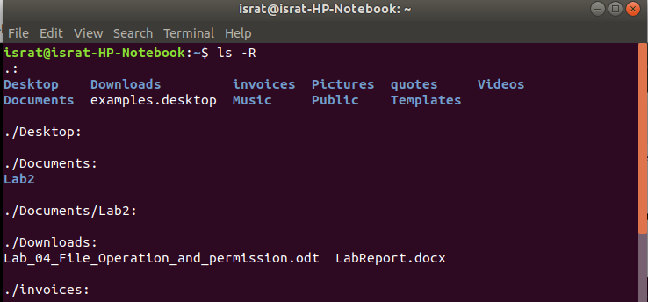

**Hide Files and Directories :** To view hidden files, run the ls command with the -a flag which enables viewing of all files in a directory or -al flag for long listing. From a GUI file manager, go to View and check the option Show Hidden Files to view hidden files or directories.

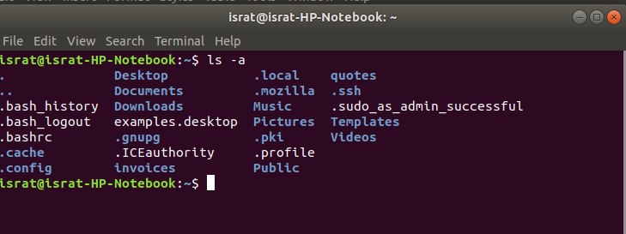

**Conclusion:** After doing this lab class , we learnt about various kinds of users and file operations and how to set permission for different users , how to add or remove different set of permissions for a or a set of users .